**AIJUS (Australia, India, Japan & USA) Space and Geospatial Business Summit**

11 July, 2025| Tokyo, Japan

Organized by Geospatial World Chamber of Commerce (GWCC)

Supported by JETRO, SpaceTide Foundation| Knowledge Partner: Geospatial World (GW)

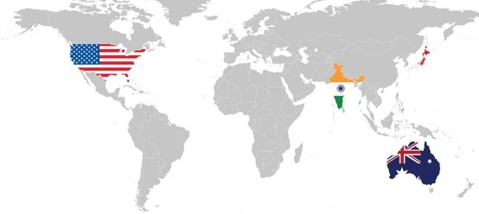

**Preamble and Rationale**

**Global Geospatial Industry and Economy (Including GNSS and EOS)**

The Geospatial industry is the next ‘Big Opportunity’ for technology companies both as an ‘advancing market in itself’ as well as ‘augmenting business processes’ of mainstream IT, Engineering and Autonomous industries. It would continue to provide accurate and rich foundation to data infrastructure and increasingly add 3rd dimension to ‘everything we do’ leading to ‘geospatial by default’ embedded in digital twin and metaverse that will impact how humans interact with digital and physical world in near-real-time.

Geospatial Infrastructure that comprises of foundation data, positioning network, platform, standards, knowledge services, and policies, provides overarching framework and enabling interface between government and commercial enterprises to work towards extending geospatial value chain and scalability of applications supporting development, governance, business, and security. Recognizing the growing value of geospatial knowledge infrastructure, there has been several initiatives towards public policy and industrial development worldwide, and the same has been laying the path for amplified growth by the year 2030 and beyond.

The Global Geospatial Market Size is estimated to be USD 452 billion in 2022 and the same is forecasted to grow at 14.61% CAGR and estimated to be USD 681 billion in year 2025. However, it’s expected to grow at much faster rate of 16.1% CAGR post 2025, making it to be USD 1.44 Trillion between 2030. While current growth rate is driven by technology innovation, integration of workflows, and augmentation of spatial analytics in business processes, but post 2025 it gains momentum due to public policy reforms and increasing investments in geospatial infrastructure (both public and private) and industry acceleration programs worldwide.

**Global Space Economy Scenario**

The global space industry is on the brink of a transformation, with projections estimating the market to reach a staggering **$1.8 trillion between 2035 - 2040**. The **United States** and **Europe** currently dominate the global space market, holding **45%** and **25%** market shares respectively. In 2025, the global space economy is projected to continue its growth, with a strong emphasis on downstream solutions and increased private sector involvement. It is expected to reach $944 billion by 2033. Additionally, according to a McKinsey report, the global space economy is estimated to be valued at $1.8 trillion by 2035 (adjusted for inflation), up from $630 billion in 2023. This growth is anticipated to support key sectors such as space manufacturing, space tourism, space-based solar power, navigation, earth observation, and telecommunications.

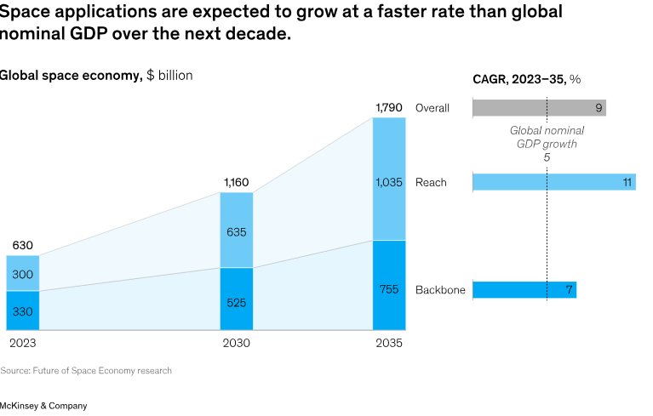

**About AIJUS (Australia, India, Japan & USA) Space & Geospatial Business Summit**

Geospatial world Chamber of Commerce (GWCC) is organising AIJUS Space & Geospatial Business Summit, a significant initiative that marks the first-ever collaboration between India, Australia, Japan, and the United States on Geospatial Infrastructure and Space Applications. This event aims to create enhanced opportunities in the geospatial and space sectors by fostering trade and commerce among these four countries. AIJUS will provide a platform for promoting international partnerships, sharing expertise, and exploring new avenues for growth and development within the geospatial and space industry. This collaboration is expected to drive innovation and strengthen the global ecosystems in the said domains.

**Australian Space and Geospatial Industry**

While specific figures for Australia's geospatial market are limited, the nation's geospatial analytics market is expected to grow from USD 32.97 billion in 2024 to USD 55.75 billion by 2029, at a CAGR of 11.1%. The nine recommendations in the 2030 Roadmap will ensure that Australia can be self-sufficient in providing essential data and services to support areas of national importance including land and water security, emergency management, autonomous systems and smart cities management. Achieving these objectives will have significant implications, such as addressing climate change, improving disaster resilience, bolstering defence, and safeguarding our critical infrastructure. [The 2030 Roadmap](https://2030spaceandspatial.com/) steers government policy makers towards Australia’s economic success, societal wellbeing and national security.

Australia has made significant strides in the geospatial industry through various initiatives and achievements that have fostered innovation, growth, and global competitiveness. These efforts are aimed at enhancing the capabilities of the industry, improving access to geospatial data, and strengthening the country’s position as a leader in geospatial technologies.

**Indian Space and Geospatial Industry**

Geospatial and space industry, that serves as foundation for digital infrastructure and economy, has been recognized as enabling and driving force towards our mission of self-reliant India. These sectors have been identified as sunrise industries, offering huge growth potential and also their enabling contribution towards India’s vision of 10 trillion economy by 2030.

**Indian Geospatial Market Economy**: India's geospatial industry has shown remarkable growth from 2023 to 2025, with the market size increasing from approximately **$6.1 billion** in 2023 to an estimated **$7.67 billion** by 2025, reflecting a compound annual growth rate (CAGR) of **12.8%**. This expansion is driven by rising demand for geospatial solutions in sectors such as infrastructure, agriculture, urban development, and disaster management. This growth is fueled by a vibrant startup ecosystem, with over 40 companies innovating in areas such as satellite design, drone applications, and launch services The Indian Space Research Organisation (ISRO) continues to play a pivotal role, having launched more than 100 domestic and over 300 foreign satellites for 33 countries. The space industry has contributed **$60 billion** to India's GDP between 2014 and 2024.

**India’s Role in the Future of Commercial Space**: India is becoming a global leader in small satellite launches and space-based applications. The liberalized space policies and active participation from private companies have created an enabling ecosystem where businesses can access India’s affordable infrastructure to scale their space initiatives and innovations. India has carved a unique position with its cost-effective and reliable space programs. Missions like Chandrayaan-3 and Mars Orbiter Mission (Mangalyaan) have demonstrated India’s ability to achieve 80% cost savings compared to Western counterparts. India, with its growing capabilities, is set to become a major player in this industry, with the space sector expected to grow to $50 billion by 2025—a 10x growth potential over the next decade.

**Japan Space and Geospatial Industry**

Japan’s geospatial industry has witnessed significant growth in recent years, driven by advancements in technology, the country’s strong focus on infrastructure development, and the integration of geospatial data into various sectors such as urban planning, disaster management, and agriculture. Japan is a leader in utilizing geospatial data for addressing challenges like natural disasters, efficient urbanization, and environmental monitoring.

### **Japan’s Geospatial Industry Market Size**: The Japanese geospatial market was valued at approximately USD 4.6 billion in 2020, with projections indicating continued growth. The sector is expected to see an average annual growth rate of 5% over the next decade. This growth is largely driven by increased demand for geospatial technologies across urban planning, construction, and disaster response sectors.

The geospatial industry in Japan spans various industries, including satellite technology, Geographic Information Systems (GIS), remote sensing, and mapping technologies. The sector is vital for applications in agriculture, disaster management, infrastructure, and environmental monitoring.

**Japan's space ecosystem** is one of the most advanced and rapidly growing in Asia, driven by a strong combination of government initiatives and private sector innovation. The Japan Aerospace Exploration Agency (JAXA) plays a central role in space research, satellite development, and deep space exploration. In recent years, Japan has increasingly focused on commercializing space activities, with private companies contributing to satellite launches, space tourism, and debris management. The country is also a key player in global space partnerships, collaborating with NASA and other international space agencies. Japan's space economy is valued at approximately **$14 billion USD** and continues to grow as the government and private companies invest in space infrastructure, satellite technology, and new space ventures.

**US Space and Geospatial Industry**

The U.S. geospatial industry is a critical part of the nation's economy. According to a report by the *National Geospatial-Intelligence Agency (NGA)*, the U.S. geospatial sector contributed approximately **USD 73.5 billion** to the economy in 2020, employing over **500,000 people** in various capacities across government agencies, private companies, and research institutions. This includes professionals working with satellite technology, spatial data analysis, and GIS solutions. With a projected annual growth rate of **8.5%**, the industry is expected to reach a market value of over **USD 100 billion** by 2025.

This growth is largely attributed to the increasing demand for accurate spatial data to support decision-making in areas like urban development, national security, climate change mitigation, and disaster management. The advancement of technologies such as high-resolution satellite imagery, drones, and machine learning is expanding the scope of geospatial applications across various sectors.

#### **NASA and Commercial Space Partnerships**: NASA plays a significant role in advancing geospatial technology, particularly in the development of satellites and space-based observation systems. The NASA Earth Science Division focuses on Earth observations, helping to monitor climate change, weather patterns, and natural disasters. In collaboration with private companies like SpaceX and Blue Origin, NASA has launched **dozens of Earth observation satellites**, supporting a growing space-based geospatial data market that is valued at over **USD 2 billion**.

The U.S. geospatial industry is a dynamic and rapidly evolving sector, playing an essential role in supporting economic growth, national security, disaster response, and environmental monitoring. Government initiatives like the National Spatial Data Infrastructure (NSDI), NASA's Earth observation programs, and private-sector innovations have helped establish the U.S. as a global leader in the geospatial field. With continued advancements in satellite technology, GIS solutions, and commercial partnerships, the U.S. is well-positioned to drive future growth in the geospatial industry.

**Trade and Commerce**

Geospatial industry traditionally has attracted very little exposure, however in past one decade, it has caught the attention of law makers and business communities, especially since Covid-19. Greater participation of commercial sector in space and geospatial sector is a well-established phenomenon globally and so as the growing support and encouragement by national governments through incubation, acceleration, strategic financing, and trade missions.

An industry that’s being seen as foundation for digital infrastructure, and is amongst fastest growing industries, and is estimated to be US$ 1 Trillion by year 2030, would but obvious attract attention in the field of global trade and commerce. Deliberations with regards to technology transfers, offsets, ease of doing business and international cooperation have begun to surface at business forums and strategic alliances.

**Potential for Geospatial and Space in the AIJUS countries**

We firmly believe that there is tremendous potential of business partnerships amongst AIJUS because the region already has multiple flexible and adaptive frameworks for security and diplomacy, including a cascading array of trilateral and bilateral formats, treaty alliances and multinational organizations. What we need is to strengthen bilateral and multilateral business forums that provide mechanisms to promote and strengthen trade and commerce in the field of geospatial and space technology amongst the partner countries. While India does have cutting edge capabilities in the field of space infrastructure and geospatial solutions and services, Australia, Japan, and US do have advanced geospatial and space technology and products and robust space industry, thereby offering potential of enhanced collaboration amongst the partner countries.

Additionally, there has been an increasingly focusing on geospatial and space cooperation to enhance regional security and to promote a free and open Indo-Pacific amongst the AIJUS partner countries. The four countries have been promoting practical cooperation in various fields, including vaccines, infrastructure, climate change, and critical and emerging technologies.

The AIJUS countrieshave been increasingly focusing on mutual collaboration to strengthen their roles in the geospatial and space sectors. Their collective efforts are enhancing geospatial data sharing, satellite technology, and spatial intelligence, all of which are crucial for addressing regional and global challenges.

* USA has been a leader in satellite technology, geospatial intelligence, and geospatial data analytics. The U.S. contributes high-resolution satellite imagery, which benefits India, Japan, and Australia, especially in urban planning, resource management, and defense, disaster management, agriculture, environmental monitoring, etc.
* Japan has strong expertise in disaster management, Early warning systems, and high-resolution satellite technology, which plays an essential role in advancing geospatial capabilities within the AIJUS countries. Japan’s experience with natural disasters (such as earthquakes and tsunamis) has led to significant advancements in early warning systems using satellite data and geospatial technologies. These systems are shared with India, Australia, and the U.S. to enhance regional disaster response capabilities.
* India’s role in the geospatial sector is increasingly significant due to its rapidly advancing satellite capabilities and geospatial data infrastructure, which has been instrumental in boosting the sector. India provides critical data from earth observation satellites to Japan, particularly in areas like disaster management and environmental monitoring. This complements Japan’s own Earth observation efforts. India’s geospatial data has been valuable to Australia, especially in environmental management, agriculture, and urban planning. The U.S. and India collaborate on satellite launches, space exploration, and sharing geospatial data, particularly for applications related to national security and disaster management.
* Interestingly, India has established itself as the leading global destination for Global Capability Centres (GCCs), with over 1,700 centres employing more than 1.5 million professionals. These GCCs have evolved into strategic hubs of innovation and advanced technology development driving significant contributions in areas such as artificial intelligence, digital transformation, product engineering, precision engineering, robotics, and advanced manufacturing and strategic decision-making for multinational corporations (MNCs) across the globe.
* Australia has been particularly active in precision agriculture, land management, and satellite navigation, offering vital resources and expertise to the other. Australia’s Geoscience Australia and AuScope programs contribute geospatial data for land management, mining, and natural resource exploration. This data is shared with other Partner countries to support sustainability efforts. Australia is a leader in precision agriculture and GNSS (Global Navigation Satellite System) technologies, which it shares with India, Japan, and the U.S. for optimizing agriculture and land-use planning.

Geo-Political alliance and bilateral/ multilateral agreements do provide an excellent business environment to leverage on the existing friendly and cultural ties to grow trade and commerce significantly on. This summit provides a unique opportunity to **tap into this ecosystem**, explore partnerships, and lower operational costs.

**About Geospatial World Chamber of Commerce (GWCC)**

Pursuing our vision of advancing trade and commerce in the field of space and geospatial industry and specially to nurture and promote Indian industry growth in international market, Geospatial World Chamber of Commerce (GWCC) – a trade and commerce organization registered as a not-for-profit company in India has been established by Geospatial World (GW) to promote trade and commerce globally. GWCC is committed towards advancing and promoting trade and commerce across geospatial and space industries worldwide through trade missions, bilateral/multilateral/regional business summits, networking and partnerships, business information services, market insights, and policy advocacy.

GWCC strives to facilitate dialogues on open trade and commerce advocating towards developing level playing fields and ease of doing business practices for commercial companies at global levels with primary partner countries of India in the context of evolving geo-political world order. We are as much committed to nurture and promote Indian industry growth in international market as we aim to facilitating participation of overseas companies in Indian market and enabling establishment of their businesses and supporting their engagement and partnership with Indian stakeholders. You may find more information at [www.GWCC.in](http://www.gwcc.in/)

**About Geospatial World (GW)**

Geospatial World (GW) is an Indian company pursuing its vision of**‘Advancing Knowledge for Sustainability’** through evangelism, advocacy, and facilitating collaborative space and geospatial eco-system and its growing relevance in economy and society. In recent past, with opening of these sectors for commercial industry, we have been working towards promotion of India as emerging market to attract FDI, Manufacturing and Transfer of Technology, as well as promoting space and geospatial solutions and services capabilities of Indian companies in global market.

**Geospatial World Chamber of Commerce**

**Corporate Office**

A-145, Sector 63, Noida – 201301 (UP), India

**Tel:** +91-120-4612500

For more information, contact us at – info@gwcc.in | www.gwcc.in