Make in India in Advancing Geospatial and Space

Industry Ecosystem
2nd Edition | International Seminar
3 December 2025 | Bharat Mandapam, New Delhi, India

Geospatial World Chamber of Commerce (GWCC), in association with Geospatial World (GW), proposes to organise the 2nd edition of International Seminar titled “Make in India in Advancing Geospatial and Space Industry Ecosystem” on 3 December, 2025. The International Seminar is a Co located event with the 25th Edition of GeoSmart India, scheduled on 2-4 December, 2025 at Bharat Mandapam, New Delhi, India.
In line with the vision of Make in India, contributing to the overarching goals of ‘Viksit Bharat’ (Developed India), the event is designed to foster global engagement with Indian industries by forming partnerships and attracting investments. Basis the recommendations and insights drawn from the 1st edition of this International Seminar, GW endeavours to continue the dialogue at the proposed forum.
The event, followed by a networking reception and dinner, shall highlight India’s pivotal role in the global space and geospatial landscape and explore opportunities created by the Make in India initiative. The ‘By Invitation’ Meet will witness dialogue and discussions among chief executives and leaders from the global geospatial and space industries. The International Seminar shall provide a platform for C-suite executives to collaborate, network, and engage with Senior Government officials, Diplomats, Trade Organisations, industry leaders, Think tanks, Research and Academia.
Key Discussions ​will
- highlight India's role in the global geospatial and space sectors and explore opportunities under the 'Make in India' initiative
- cover the transformation of the geospatial and space ecosystem for national development, focusing on innovation, manufacturing, and export potential ​
- explore upstream and downstream opportunities in the space sector, including satellite manufacturing and applications
- address the potential for geospatial hardware and software development, emphasizing policy reforms and the role of emerging technologies like AI and IoT ​
- focus on overcoming industry challenges (e.g. scaling manufacturing, skill gaps)
- deliberate on strategies for attracting Foreign Direct Investment (FDI) in manufacturing, software, and hardware segments

Expected Outcomes
- To foster strategic partnerships and international collaboration
- To provide platform for knowledge sharing and policy advocacy to enhance India's geospatial and space sectors ​
- To explore opportunities for domestic joint ventures and projects, contributing to national development and economic growth​

Key Features
- Leadership Dialogue involving conversations with top-tier industry professionals who are shaping the future of the geospatial and space sectors.
- Industry-Specific Focused discussions centered around the unique challenges and opportunities within the geospatial and space industries in the context of Make in India.
- Collaboration and Networking towards fostering collaboration and allowing leaders to build relationships with peers and other key stakeholders in the industry.
- Strategic Insights into emerging trends, market strategies, and technological advancements that are driving these industries forward.
- Platform for Growth for career advancement, unlocking global opportunities, and promoting diversity and inclusivity within the geospatial and space ecosystems.
In essence, the networking discussions shall aim to align stakeholders around a common roadmap for India’s space and geospatial sunrise sectors, leveraging policy support under Make in India to attract technology, investment and skills.
Make in India Initiative: An Overview
Background
Launched in September 2014 by Prime Minister Narendra Modi, the Make in India initiative aims to transform India into a global manufacturing hub by fostering innovation, self-reliance and sustainable growth. Key goals include boosting manufacturing growth to 12–14% annually, creating 100 million jobs by 2022, and raising manufacturing’s share of GDP to 25% by 2025. The initiative is built on four main pillars –
- New Processes (ease of doing business and deregulation),
- New Infrastructure (industrial corridors, smart cities, upgraded logistic networks),
- New Sectors (25 priority manufacturing and service sectors), and
- New Mindset (government as facilitator, not regulator).
Make in India, From the outset, aimed to encourage investment (both domestic and foreign), spur innovation, develop skilled labour, protect intellectual property, and build world-class industrial capacity. These changes have strengthened India’s economic credibility on the global stage, setting the country on a path toward becoming a leading world economy.

Key Approaches and Reforms
To kickstart manufacturing, the government significantly liberalized policies and streamlined processes.
- Under Make in India, 100% FDI is permitted in most sectors, with only a few restrictions (e.g. space, defense, media). New single-window clearance systems (e.g. the National Single Window) and IT-based platforms have been introduced to integrate approvals across central and state agencies, cutting red tape. For example, over 40,000 regulatory compliances have been eliminated, and many minor offenses have been decriminalized to ease doing business. Labour laws were rationalized and environmental clearances digitized, reflecting the program’s emphasis on ease of doing business.
- At the same time, India invested in infrastructure to support industry. Dozens of new industrial corridors (e.g. Delhi–Mumbai, Chennai–Bengaluru), Dedicated Freight Corridors, and “smart” industrial parks were announced or built.
- The PM Gati Shakti master plan for multimodal infrastructure was launched to lower logistics costs and improve connectivity across states, directly addressing one of the key bottlenecks to competitiveness.
- Importantly, the initiative also actively opened up new sectors: critical industries like defense production, railways infrastructure, and space have seen relaxed caps on foreign investment to attract technology and capital.
In short, the government aimed to build “the transparent, user-friendly system” needed to make India an attractive manufacturing base.

Growth and Achievements
The decade since Make in India has seen mixed but notable outcomes. Manufacturing growth has generally trended upward in recent years, and India has attracted record investment flows:
- Manufacturing output growth: Industrial production has rebounded. For example, in July 2025 India’s Index of Industrial Production (IIP) grew 3.5% year-on-year, led by a 5.4% rise in manufacturing output. Key industries such as basic metals, machinery, and electrical equipment have all recorded double-digit growth recently. These gains reflect rising capacity utilization and stronger demand both domestically and from exports.
- Exports: Manufacturing-led exports have remained strong. In the first half of FY2025–26 (Apr–Aug 2025), merchandise exports were up 2.5% year-on-year to over US$184 billion. India’s positioning in global supply chains has improved, especially in areas like pharmaceuticals and auto parts.
- Foreign Direct Investment (FDI): India has become a magnet for investment. FDI inflows hit a new high – about US$81 billion in FY2024–25 – and manufacturing FDI alone reached over US$19 billion (up 18% from FY2023–24). Over the 2014–24 decade, FDI into manufacturing jumped by roughly 69%, from ₹8.37 lakh crore to ₹14.15 lakh crore. The government attributes this to Make in India and related policies (like the Production-Linked Incentive – PLI – schemes) that made India more attractive to global investors. Major international partnerships have also formed: for instance, agreements with Japan and Europe (including a ₹5 lakh crore Japan-India fund) aim to channel technology into semiconductors and industrial projects.
- Industrial Milestones: India has seen significant growth in key sectors. The automotive industry, as a case in point, contributes about 7.1% of GDP and 49% of manufacturing GDP, and India is now the world’s fourth-largest auto producer. In electronics, India has become the second-largest mobile phone manufacturer globally in the last decade. The textile and apparel sector has also grown as planned – it accounts for ~2.3% of GDP, and initiatives like the PM-MITRA textile parks (with a budget of ₹4,445 crore) aim to attract ₹70,000 crore investment and generate 3 million jobs by 2030.
- In defense, a new ecosystem is emerging: increase in indigenous Defence production. Defence exports have risen to INR 23000 crore in the last fiscal, more than 3 times what we exported 3 years ago. Production of weapons (e.g. AK-203 rifles, BrahMos missiles) is ramping up, and India’s defense FDI cap has been raised (to 74% auto, 100% government route). Railways freight capacity has also increased and so has the surge in Blue water economy been witnessed.
- Job Creation and Skills: The focus on “Make” has also helped absorb labor. Official data indicate around 17 million jobs were created in the last decade, with manufacturing contributing significantly. The government has expanded skills training (e.g. revised Skill India program with ₹8,800 crore till 2026) to ensure industries have trained workers. Participation in the workforce, including among women, has been rising alongside industrial growth. Indeed, surveys show manufacturing’s share in total employment has picked up compared to pre-2014 trends.
- Enabling Initiatives: Several newer schemes under “Make in India” have started to deliver results. The PLI scheme (launched 2020) for 14 manufacturing sectors has, by mid-2025, attracted over ₹1.4 lakh crore in committed investments, generated output worth about ₹12 lakh crore, and created roughly 850,000 jobs. For example, the semiconductors push (Semicon India program, ₹76,000 crore outlay) aims to seed-chip fabrication in India. The Government e-Marketplace (GeM) platform – partly an offshoot of the broader push for self-reliance – now connects ~2.5 million small sellers and procured ₹15 lakh crore in goods, a sizeable share of which (about ₹7 lakh crore) came from MSMEs. Digital public goods (UPI, Aadhaar, DigiLocker, ONDC) have also been highlighted by the PM as part of building infrastructure that benefits all entrepreneurs.

Challenges and Critiques
While there has been significant growth, yet the defined targets have not been accomplished. In particular, the manufacturing sector’s contribution to GDP has been roughly flat or even declined slightly. Government and analysts note that manufacturing’s share was ~16.7% of GDP in 2013–14 and around 15.9% in 2023–24 (constant prices) – far below the 25% goal. Even accounting differences (current vs constant prices) give similar results: one estimate pegs manufacturing at about 14% of GDP in 2024–25. In short, the sector has only marginally grown its GDP share over a decade.
Experts point to several factors behind this shortfall. Infrastructure bottlenecks and high logistics costs have kept manufacturing less competitive globally. The DPIIT Secretary has noted that gaps in technology and skills mean that simply pouring in capital does not automatically translate to output – investment must be coupled with technology transfer and capacity building. Other issues include land acquisition hurdles (though somewhat eased), complex tax and regulatory regimes (partly tackled by GST and reforms), and global competition from lower-cost neighbours. For example, India still lags countries like Vietnam and Mexico on export competitiveness, often due to supply-chain costs rather than factory-gate costs.
It has been observed that while large projects were announced, many small manufacturers found compliance burdensome (hence the recent compliance cuts). The decline in manufacturing’s GDP share suggests that growth has not kept pace with the overall economy or created enough jobs as fast as envisioned. (This was actually acknowledged by the government itself in 2024.)

Outlook
As of 2025, India’s manufacturing sector is growing faster, driven by record investments and reforms. Policymakers project that with continuing liberalization and strategic incentives, manufacturing could reach closer to the 25% GDP goal by the end of the decade. India’s young workforce and massive domestic market – nearly unique among large economies – are strengths that complement Make in India. With policy predictability and global supply chains diversifying, international confidence is rising: analysts note India is poised to be a “leading global hub for FDI,” especially in manufacturing and technology.
In the government’s own words, India’s resolve remains strong: disruptions (like pandemics or geopolitical shifts) have “revealed new directions” rather than deterred the Make in India mission. Continued focus on ease of business, investment in R&D, and quality standards aims to sustain this momentum. If these trends hold, India may well advance significantly toward its long-term vision of becoming a developed, industrialized economy by 2047, with manufacturing playing a central role.
__________________________
Rationale and Context: ‘Make in India’ in Space and Geospatial Sectors
Global Geospatial Industry and Economy (Including GNSS and EOS)
The geospatial industry (encompassing GIS, GNSS, Earth Observation, mapping and related services) is experiencing rapid growth worldwide. It is projected to play a critical role in emerging technologies like digital twins and the metaverse, embedding real-world spatial data into business and consumer applications. Industry analyses estimate that the global geospatial market was worth about USD 452 billion in 2022, and is expected to grow at a CAGR of roughly 14–15% to reach USD ~646–681 billion by 2025. After 2025 the growth is forecast to accelerate (around 16.1% CAGR), with the market reaching ~USD 1.44 trillion by 2030. Key drivers include technological innovation (e.g. AI-powered analytics, drones, satellites), strategic public policies, and increased investments in geospatial infrastructure globally.

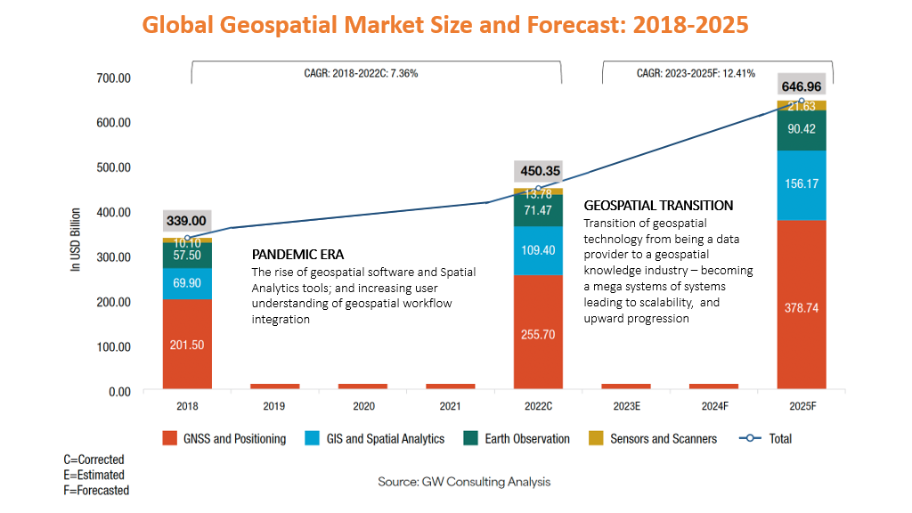
- Market Size (Global): ~USD 452 B (2022); ≈USD 646–681 B (2025); ~USD 1.44 T (2030).
- Growth Drivers: Integration of geospatial data in digital twins/metaverse, GNSS and Earth-Observation services, and strong investment in geospatial technology.
This explosive growth underscores the strategic importance of geospatial data as “the foundation for digital infrastructure,” providing critical insights for industries ranging from IT and engineering to agriculture and transportation. Governments and enterprises worldwide are incorporating a “geospatial-by-default” approach into urban planning, disaster management, and consumer applications, greatly expanding the market.
Geospatial Infrastructure that comprises of foundation data, positioning network, platform, standards, knowledge services, and policies, provides overarching framework and enabling interface between government and commercial enterprises to work towards extending geospatial value chain and scalability of applications supporting development, governance, business, and security. Recognizing the growing value of geospatial knowledge infrastructure, there has been several initiatives towards public policy and industrial development worldwide, and the same has been laying the path for amplified growth by the year 2030 and beyond.
Global Space Economy Scenario
The global space industry is on the brink of a transformation, with projections estimating the market to reach a staggering $1.8 trillion by 2040. The United States and Europe currently dominate the global space market, holding 45% and 25% market shares respectively. In 2025, the global space economy is projected to continue its growth, with a strong emphasis on downstream solutions and increased private sector involvement. It is expected to reach $944 billion by 2033. Additionally, according to a McKinsey report, the global space economy is estimated to be valued at $1.8 trillion by 2035 (adjusted for inflation), up from $630 billion in 2023. This growth is anticipated to support key sectors such as space manufacturing, space tourism, space-based solar power, navigation, earth observation, and telecommunications.

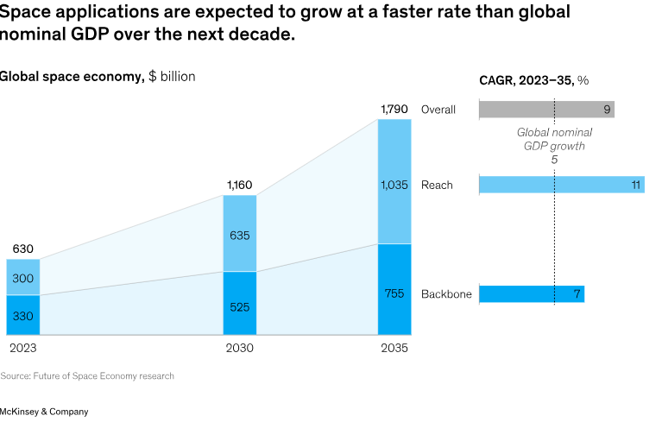

India’s Geospatial and Space Sectors
India is a major player in the geospatial and space industries, and these have been explicitly identified as “sunrise sectors” under Make in India. The Indian geospatial economy (covering mapping, surveys, GIS, etc.) was estimated at around USD 5.0 billion in 2021, including roughly USD 1.6 billion in services exports. This makes India one of the largest geospatial markets globally. Ongoing policy reforms – such as liberalized geospatial data guidelines, National Geospatial Policy 2022, the Drone Rules 2021, and Space data policies, National Space Policy 2023 – coupled with growing international cooperation, are expected to accelerate growth. Experts note that the geospatial sector “serves as foundation for digital infrastructure and economy” and is a key driver toward India’s vision of a $10 trillion economy by 2030.
- Indian Geospatial Market: ~USD 5 B (2021); ~USD 1.6 B exported.
- Government Focus: Liberalization of geospatial data, drone and space policies; identification as a critical “sunrise industry” for Atmanirbhar Bharat.
In the space sector, India’s achievements (e.g. ISRO missions, satellite launches) have laid a foundation for rapid expansion. India’s own space economy was estimated at USD 8.4 billion in 2023; with an expanding private sector, it could grow to about USD 44 billion by 2033. This surge will be driven by new space-tech startups and a growing ecosystem of private “Non-Government Entities” (NGEs) for manufacturing and services. Crucially, recent liberalization under Make in India – such as opening launch and satellite manufacturing to private firms – has stimulated domestic R&D and investment across the entire space value chain.
- Global Space Economy: USD 630 B (2023); forecasted $1.8 T by 2035.
- Indian Space Sector: USD 8.4 B (2023); projected to USD 44 B by 2033.
The Make in India initiative is further boosting these sectors by encouraging innovation and foreign investment. For example, policy reforms have allowed greater FDI and private participation in space and geospatial activities, spurring new startups and partnerships. The government’s push to integrate advanced space and geospatial technologies into national projects (e.g. smart cities, resource mapping, defense) is creating new domestic demand and export opportunities.

Software Development and Solutioning: Catalysts for Growth
The "Make in India" initiative is increasingly powered by the software development and solutioning sectors within the space and geospatial industries. These sectors, leveraging satellite technology and geospatial data, are driving advancements in areas like national security, resource management, disaster relief, precision agriculture, urban planning, and more. The growth of start-ups in this space, supported by initiatives like Start-up India, is creating significant employment opportunities for software engineers, data scientists, and geospatial analysts, particularly in tier-2 and tier-3 cities. India's global competitiveness in software solutions, especially in satellite data analysis and GIS, is positioning the country as a leader in these domains. With a focus on innovation, public-private partnerships, skill development, and investment in high-tech infrastructure, the sector is poised to contribute substantially to economic growth while addressing societal challenges and fostering sustainable development.
- Innovation Areas: AI-driven satellite data analysis, GIS-based decision support, location intelligence for smart cities, and environmental monitoring.
- Employment Impact: Rapid growth of startups (often under Startup India) is creating jobs for engineers, analysts and data specialists across the country.
- Competitive Edge: India’s strong IT and analytics ecosystem, especially firms experienced in satellite data processing and GIS, is positioning it as a global leader in geospatial software solutions.
Public–private partnerships and investments in R&D are emphasized to sustain this momentum. By focusing on skill development and high-tech infrastructure, policymakers aim to ensure that the space and geospatial software sectors drive exports and address domestic challenges (e.g. crop monitoring, climate resilience) in a sustainable manner.

Trade, FDI and Global Integration
International trade and investment are integral to the growth of India’s space and geospatial sectors. Over the past decade, these industries have attracted global attention: foreign governments and companies are forming joint ventures, and trade missions and tech financing are common. Under Make in India, policy changes have accelerated this trend. Indian geospatial services exports (USD 1.6 B in 2021) are expected to grow rapidly with eased regulations and government support. Indeed, some forecasts suggest that the global space–geospatial sector could reach USD 1 trillion by 2030, with India capturing a significant share.
- Exports: Indian geospatial services exports ~USD 1.6 B (2021), with strong growth expected due to new opportunities abroad.
- FDI Inflows: Liberalized policies (e.g. easier FDI in defense, space launches, satellite manufacturing) are drawing foreign investment and technology transfer.
- International Collaboration: India is deepening partnerships (bilateral space pacts, global GIS projects) and emphasizing ease-of-doing-business to integrate with the world economy.

Make in India’s reforms in trade and commerce are positioning India as a hub for space and geospatial technology. Multinationals are increasingly open to “manufacture in India” or outsource R&D here, further driving exports and economic growth.

Way Forward & Future Directions

Recognizing the gaps, the government has doubled down on reforms.
- The ease-of-doing-business agenda continues: recent updates to the Companies Act and a new Trademark Law aim to simplify legal procedures for industry. GST “2.0” reforms (implemented in September 2025) have reduced tax slabs and eased compliance further, especially benefiting MSMEs. The removal of thousands of regulations and the creation of single-window clearance portals aim to shorten project approval times.
- Strategic initiatives are also being expanded. The PLI schemes are being extended and optimized; for example, electronics and pharmaceuticals PLI schemes continue to attract investment into value-added sectors. The government is also working on a national semiconductor policy to attract chip manufacturing (in line with PM Modi’s “chips to ships” vision), as global firms seek alternatives to China.
- Heavy investment is going into defense manufacturing under the initiative. In renewable energy, policies such as 100% FDI in greenfields and incentives for solar/ battery plants are aligning with Make in India goals (often labeled “Make in India – Green Edition”).
- The government has also underscored quality and innovation as critical and emphasised on investing in R&D. This reflects an understanding that self-reliance must be coupled with global competitiveness. Accordingly, funding for research (in areas like electronics, aerospace, biotech) is being raised, and public–private research collaborations are encouraged. For instance, new schemes offer grants for industry-academia projects, and India is working to retain talent and reverse past “brain drain.” The recent policy focus is on creating a full ecosystem – from design to manufacturing – within India.
- Integration with Atmanirbhar Bharat -Make in India has increasingly been framed as part of the broader Aatmanirbhar Bharat (self-reliant India) campaign. Initiatives like Make in India and Atmanirbhar Bharat share themes of swadeshi (self-made goods), local entrepreneurship, and inclusive growth. Schemes like PM SVANidhi and GeM tie into the Make in India ethos by broadening the manufacturing and services base. Make in India’s success, in this narrative, is not just factory output but also creating a holistic ecosystem where local companies – large and small – supply to big projects and global markets alike. Even beyond traditional manufacturing, policies around digital infrastructure (e.g. open finance/ fintech platforms) are seen as supporting the entrepreneurial environment that Make in India envisioned.

_____________________________
Recommendations from 1st Edition of Make in Indiain Advancing Geospatial and Space Industry Ecosystem
India’s strategic vision of becoming a global technology powerhouse places the space and geospatial sectors at the heart of national development, digital transformation, and economic growth. Aligned with the “Make in India” vision, following comprehensive strategic recommendations aim to foster innovation, strengthen competitiveness, and position India as a global leader in space and geospatial technologies.
- Position India as a Global Exporter of Solutions Move beyond services to export scalable software, hardware, and integrated platforms globally. Move India from a service hub to a product-creation nation with exportable hardware and software.
- Build an Integrated Space and Geospatial Ecosystem Develop a unified ecosystem combining space infrastructure, ground segments, data processing centers, and service platforms. This will support national needs such as disaster management, urban planning, and environmental monitoring, while enabling efficient service delivery to the private sector and government agencies.
- Encourage Public-Private-Academia Collaborations Create institutional frameworks where academia, start-ups, and corporates co-develop solutions with government support.
- Enhance Private Sector Empowerment and Investment Attraction Simplify regulatory frameworks and offer incentives to attract private investment. Enable private enterprises to develop satellite constellations, “satellite-as-a-service” solutions, and commercial ground systems.
- Strengthen Localization and Indigenous Innovation Promote the development of high-resolution imaging systems, advanced payloads, and launch vehicle components within India. This will advance self-reliance, create resilient supply chains, and support national security priorities.
- Deepen International Collaboration and Market Expansion Forge strong partnerships with like-minded countries to co-develop technologies, share best practices, and expand India’s market share in the $550 billion global geospatial services economy. To strengthen access to Global Markets, there is a need to build trade agreements for Indian geospatial exports and integrate with international standards.
- Accelerate Development of National Digital Twin Platforms Implement a National Digital Twin platform to integrate geospatial data, including both above-ground and underground infrastructure. This will facilitate advanced urban planning, predictive diagnostics, and data-driven governance aligned with the PM Gati Shakti vision.
- Promote Sector-Specific AI-Driven Applications Stimulate development of domain-focused AI solutions for agriculture, health, urban planning, and mobility. These applications will provide actionable insights for real-time decision-making and targeted problem-solving.
- Advance Regulatory Frameworks and Data Integration Strengthen legal frameworks for geospatial data privacy, interoperability, and secure cross-sector data sharing. Empower a single-window clearance system to accelerate approvals and enhance data accessibility for efficient governance.
- Leverage Startup Ecosystem for Innovation and Growth Capitalize on India’s dynamic startup ecosystem by providing incubation support, targeted funding, and technical mentorship. This will accelerate the development of indigenous space and geospatial solutions.
- Facilitate Collaborative Knowledge Exchange Platforms Establish structured forums for government, industry, academia, and startups to collaborate, share innovations, and co-develop solutions. This will bridge the gap between research and commercial deployment.
- Harness Demographic Dividend and Build Capacity at Scale Implement large-scale programs focused on geospatial education, vocational training, and skill development to empower India’s young workforce.
- Mandate Geospatial Technology Adoption in Infrastructure Development Require geospatial technologies in large infrastructure projects to ensure improved precision, cost-efficiency, and environmental sustainability during road construction, railway projects, and urban development.
- Prioritize Sustainability in Geospatial Solutions Integrate green mobility solutions such as mapping EV charging stations and fuel-efficient routing to reduce carbon emissions and support the growth of India’s electric vehicle ecosystem, particularly in the two-wheeler market.
- Leverage Satellite Communication for Real-Time Governance Data Expand satellite-based networks to deliver real-time data in remote and underserved regions, enabling data-driven decision-making in health, education, agriculture, and disaster management.
- Promote Digital Twinning for Future Urbanization Advance the use of digital twin technologies to plan and manage smart cities. This is critical as India is expected to add over 500 million urban residents by 2070, requiring smarter infrastructure solutions.
- Institutionalize User-Generated Data Contributions Support and recognize community-based contributions to geospatial datasets (e.g., road edits, POIs), enhancing data accuracy, reliability, and relevance for local decision-making.
- Ensure Sustainability and Ethical Data Use Implement robust data governance policies to ensure privacy, ethical AI usage, and responsible handling of geospatial data. These principles will build public trust and ensure long-term sustainability of digital initiatives.

Conclusion
By fostering innovation, enhancing regulatory clarity, promoting collaboration, and investing in talent development, India is well-positioned to unlock economic opportunities, technological sovereignty, and global leadership in space and geospatial sectors.

References: pmindia.gov.in; gwcc.in; geospatialworld.net; newindianexpress.com; india-briefing.com; ibef.org; pib.gov.in; www.makeinindia.com

Geospatial World Chamber of Commerce
Corporate Office
A-145, Sector 63, Noida – 201301 (UP), India
Tel: +91-120-4612500
For more information, contact us at – info@gwcc.in | www.gwcc.in

